# **FROM 1st July TO 9st July**

# **Project ID:**

# **2021J_BV01_BCI Browser**

# **Project Title:**

# **Design and development of Brain Computer Interface Browser on Web and Mobile**

# **Summary:**

The dataset contains raw and pre-processed EEG data from a mobile EEG study investigating the additive effects of task load, motor demand, and environmental complexity on attention.

A knowledge repository is an online database that systematically captures, organizes, and categorizes knowledge-based information. Knowledge repositories are most often private databases that manage enterprise and proprietary information.

# **Detail:**

DATA SET

This dataset contains raw and pre-processed EEG data from a mobile EEG study investigating the additive effects of task load, motor demand, and environmental complexity on attention.

Details about the experiment

Forty-four healthy adults aged 18-40 performed an oddball task involving complex tone (piano and horn) stimuli in three settings:

(1) sitting in a quiet room in the lab (LAB);

(2) walking around a sports field (FIELD);

3) navigating a route through a university campus (CAMPUS).

Participants performed each environmental condition twice: once while attending to oddball stimuli (i.e. counting the number of presented deviant tones; COUNT), and once while disregarding or ignoring the tone stimuli (IGNORE).

EEG signals were recorded from 32 active electrodes using a Brain Vision LiveAmp 32 amplifier.

Example:-

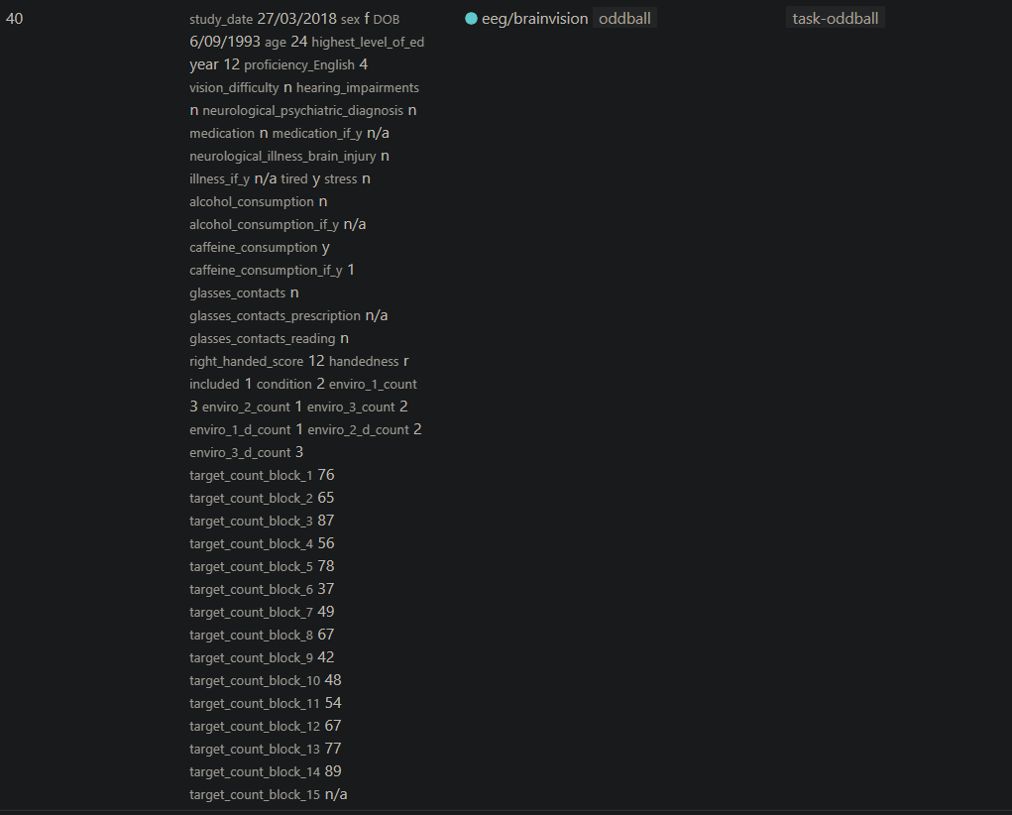

|  |  |
| --- | --- |
| onset | REQUIRED. Onset in seconds from the beginning of the recording. ‘n/a’ if it affects the entire recording. If ‘n/a’, duration must also be ‘n/a’. |
| duration | REQUIRED. Duration in seconds. 0 for instantaneous events. ‘n/a’ if it affects the entire recording. If ‘n/a’, onset must also be ‘n/a’. |
| label | REQUIRED. Label for the annotation. Can be a list of annotations separated by comma. |
| channels | OPTIONAL. Label specific to a channel. If ‘n/a’, applies to all the channels. Else, it must be a list of channel names or labels for the time series (e.g., name of ICA component). |
| absolute_time | OPTIONAL. Onset in absolute datetime which should be expressed in the following format 2009-06-15T13:45:30 (year, month, day, hour (24h), minute, second; this is equivalent to the [RFC3339](https://tools.ietf.org/html/rfc3339) “date-time” format, time zone is always assumed as local time).  If the corresponding unprocessed source file has been anonymized, using BIDS convention: i.e., time stamps have been shifted by a randomly chosen number of days, then the absolute_time must also be shifted by the same amount.  The advantage of providing absolute_time is that it is unaffected by signal cropping or resampling. |
| description | OPTIONAL. Free form text further describing the event. MUST be “n/a” if no further description for an event is present. If no event has a “description”, the whole column SHOULD be omitted. |

**Note: Onset and duration in seconds vs. samples**

We considered storing the onset in seconds as opposed to samples. The advantage of storing in samples is that it is more precise and prevents rounding errors. However, this can be ambiguous e.g., in the case of EDF files which have channels in different sampling rates. It is also not robust against resampling. Furthermore, BIDS has historically stored event times in seconds and thus it would be more consistent. For these reasons, we choose to express these quantities in seconds.

Examples:

derivatives/

hcp-preprocessed/

sub-control01/

ses-01/meg/sub-control01_ses-01_task-rest_run-01_annotations.tsv:

**Example 1**: annotation for events only

|  |  |  |
| --- | --- | --- |
| **onset** | **duration** | **label** |
| 1.2 | 1.000 | bad_eye_blink |
| 8 | 10.000 | bad_motion |
| 10 | 3 | radio_on |

**Example 2**: annotation for events and entire channels

|  |  |  |  |
| --- | --- | --- | --- |
| **onset** | **duration** | **label** | **channels** |
| n/a | n/a | artifact, line_noise | [‘EEG002’] |
| 1.2 | 1.000 | eye_blink | n/a |
| 8 | 10.000 | artifact, motion | [‘EEG001’, ‘EEG004’] |
| 10 | 3 | radio_on | n/a |

**Example 3**: annotation for ICA components

|  |  |  |  |
| --- | --- | --- | --- |
| **onset** | **duration** | **label** | **channels** |
| n/a | n/a | eye_blink | [‘ICA001’] |
| n/a | n/a | heart_beat | [‘ICA015’, ‘ICA018’] |

**Recommended labels**

Here is a list of RECOMMENDED labels to use for certain types of annotations:

* **artifact:** artifactual data
* **motion:** motion related artifact
* **flux_jump:** artifactual data due to flux jump
* **line_noise:** artifactual data due to line noise (e.g., 50Hz)
* **muscle** : artifactual data due to muscle activity
* Epilepsy_interictal: period deemed interictal
* **epilepsy_preictal:** onset of preictal state prior to onset of epilepsy
* **epilepsy_seizure:** onset of epilepsy
* **epilepsy_postictal:** postictal seizure period
* **epileptiformepilepsy_spike : epileptic spike:** unspecified epileptiform activity
  + **epileptiform_single**: a single epileptiform graphoelement (including possible slow wave)
  + **epileptiform_run**: a run of one or more epileptiform graphoelements
* **eye_blink:** Eye blink
* **eye_movement:** Smooth Pursuit / Saccadic eye movement
* **eye_fixation:** Fixation onset
* **sleep_N1:** sleep stage N1
* **sleep_N2:** sleep stage N2
* **sleep_N3:** sleep stage N3
* **sleep_REM:** REM sleep
* **sleep_wake:** sleep stage awake
* **sleep_spindle** : sleep spindle
* **sleep_k-complex** : sleep K-complex

**FilterProperties**

|  |  |
| --- | --- |
| FilterType | RECOMMENDED. Could be ‘low-pass butterworth’, ‘high-pass fir’, ‘band-pass iir’, etc. |
| HighCutoff | RECOMMENDED. Cutoff at which higher frequencies are attenuated. |
| LowCutoff | RECOMMENDED. Cutoff at which lower frequencies are attenuated. |
| HighCutoffDefinition | RECOMMENDED. Can be “half-amplitude (-6dB)” or “half-power (-3dB)” |
| LowCutoffDefinition | RECOMMENDED. Can be “half-amplitude (-6dB)” or “half-power (-3dB)” |
| FilterOrder | RECOMMENDED. The order of the filter. |
| FilterLength | OPTIONAL. The length of the filter |
| RollOff | OPTIONAL. Could be “12 dB/Octave”, etc. |
| TransitionBandwidth | OPTIONAL. Could be “10 Hz”, etc. |
| PassbandRipple | OPTIONAL. |
| StopbandAttenuation | OPTIONAL. |
| FilterDelay | OPTIONAL. Could be “linear-phase” or “non-linear-phase” |
| FilterCausality | OPTIONAL. Could be “causal” or “non-causal” |
| Direction | RECOMMENDED. Could be ‘forward’, ‘backward’ or ‘bidirectional’ |
| DirectionDescription | REQUIRED if “Direction” is “bidirectional”. Else OPTIONAL. Could be “cutoff frequencies and filter order apply to a single filter pass” or “cutoff frequencies and filter order apply to the final two-pass filter” |
| Purpose | OPTIONAL. ‘antialiasing’ |

## 4.3 Downsampling

|  |  |
| --- | --- |
| SamplingFrequency | REQUIRED. Sampling frequency after downsampling. Anti aliasing filters used in this procedure should be specified as in filtering. |
| IsDownsampled | RECOMMENDED. Boolean ‘true’ if data are downsampled. |

{

"Description": "Data Filtering",

"Sources": ["sub-01_ses-01_task-rest_meg.fif"],

"Filters": {

"LowPass": {

"LowCutoff": 100, "FilterType": "butterworth",

"FilterOrder": 4,"Direction":"bidirectional"

},

}

}

## Re-referencing and projection

Linear data projections such as re-referencing (EEG, iEEG) and 3rd order gradient projections (MEG) can be saved. A projection matrix should be saved in a .tsv file that specifies how the hardware electrode contacts map onto the channels in the data.

When data are re-referenced, the projection matrix should be saved as a .tsv file:

<dataset>/

derivatives/

<pipeline-name>/

sub-<label>/

[ses-<session-label>]/

<meg|eeg|ieeg>/

<source_keywords>_desc-<label>_proj.tsv

The first row and the first column should be matching and correspond to the names of the channels.

Example of the .tsv file:

**Example 1:** Average reference

|  |  |  |  |
| --- | --- | --- | --- |
| output_name | O1 | O2 | P1 |
| O1 | 0.66 | -0.33 | -0.33 |
| O2 | -0.33 | 0.66 | -0.33 |
| P1 | -0.33 | -0.33 | 0.66 |

**Example 2:** Bipolar reference or fancy stuff

|  |  |  |  |
| --- | --- | --- | --- |
| output_name | O1 | O2 | P1 |
| O1-O2 | 1 | -1 | 0 |
| O2-P1 | 0 | 1 | -1 |
| fancy | 1 | -0.5 | -0.5 |

Each row in the matrix shows how the data in the channel should be weighted by different channels.

## 2 Data shape and folder structure

Data could be stored in:

1) _epochs.mat: with dimensions epochs x channels x timepoints

Note that segmented data allows for different segment lengths, i.e. it is not required for the data to fit into a 3-D array. In the case of different epoch lengths: the matrix should be padded (e.g. with zeros or NaN) and the different time durations appropriately specified in the sidecar .tsv file. The software reading the data will know where to truncate based on the .tsv sidecar. See Example 2 below for clarification.

2) _average.mat: with dimensions channels x timepoints.

The mat file SHOULD store only a single matrix in order to maximize interoperability between software. All the metadata should be stored in sidecar files described below.

Template:

<dataset>/

derivatives/

<pipeline-name>/

sub-<label>/

[ses-<session-label>]/

<meg|eeg|ieeg>/

<source_keywords>_src-<source_suffix>_desc-<label><_epochs|average>~~.mat~~ .edf

<source_keywords>_desc-<label>_<epochs|average>.tsv

<source_keywords>_desc-<label>_<epochs|average>.json

<source_keywords>_desc-<label>_channels.tsv

**KNOWLEDGE REPOSITORY**

A knowledge repository is an online database that systematically captures, organizes, and categorizes knowledge-based information. Knowledge repositories are most often private databases that manage enterprise and proprietary information.

* Knowledge from all projects must be documented and collected.
* This knowledge should be organized into a repository that will support decision making for future projects.
* Organization should provide resources and funds for this activity.

There are several key features of effective digital knowledge repositories:

* Centralization. A wide variety of digital courseware, and content curated from multiple sources, can be housed in a central location where it can be tagged, shared and commented upon globally within one consistent interface.
* Content management. The breadth of learning content can include audio visual files, simulations, data, learning modules, articles, blogs, YouTube videos, best practices guidance, monitoring capabilities and contact information. Content is searchable by key words, learning outcomes, and other vehicles.
* Cost savings. Repositories can potentially reduce the cost of training and education by making affordable course materials accessible, reducing the need for classroom training and stimulating productive informal learning.
* Access control. By restricting individual content pieces via password authentication and other security functionality, curators can accomplish various goals. Access controls often involve safeguarding proprietary information and protecting intellectual property. Some, but not all, repositories employ digital rights management (DRM) to protect and monetize intellectual property in the market.
* Record management. Repositories can integrate with learning management systems to blend seamlessly into learning and talent management programs.

In BCI Framework, integrating data related to different brain signals in knowledge repository.

Taxonomy of BCI signal paradigms according to the acquisition methods. ECOG: Electrocorticography, EEG: Electroencephalography, fNIRS: functional near-infrared spectroscopy, fMRI: functional magnetic resonance imaging, EOG: Electrooculography, MEG: Magnetoencephalography.

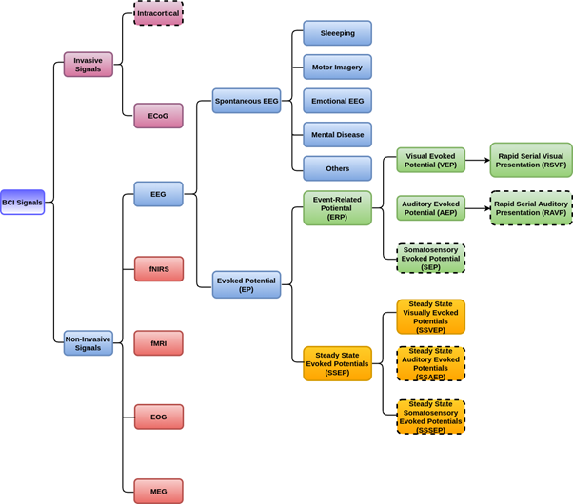

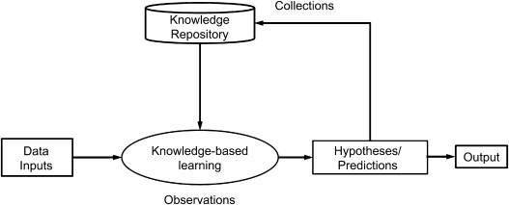

**Figure: Basic Flowchart of Knowledge Repository**

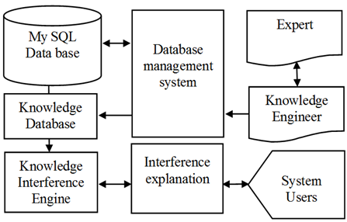

**Figure: DBMS Structure**

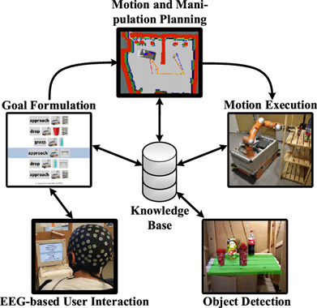

**Figure : Application of Knowledge Base in BCI**

**CONCLUSION-:**

Thus, datasets containing EEG signals make a significant part of the BCI knowledge repository. A wide variety of digital courseware, and content curated from multiple sources, can be housed in a central location where it can be tagged, shared and commented upon globally within one consistent interface.